Household and Electrical products
(Background photo change to the new photo attached)

WIRE & CABLE MANUFACTURING MATERIALS FROM JAPAN
We have been imported following products from our supplier from Japan. The products are complete materials for wire and cable manufacturing industry.
List of products are given below:
COPPER WIRE, ALLOY WIRE, STRANDED WIRE, TIN-PLATED WIRE, SILVER-PLATED WIRE, NICKEL WIRE, ALUMINUM WIRE, ELECTRIC RESISTANCE WIRE, THERMOCOUPLE ALLOY WIRE, ENAMELED WIRE, MICRO COAXIAL CABLE, WIRE DRAWING DIES, DIE & NIPPLE, ENAMELING DIES, BOBBINS, DRUMS, BOBBIN CLAMPS.
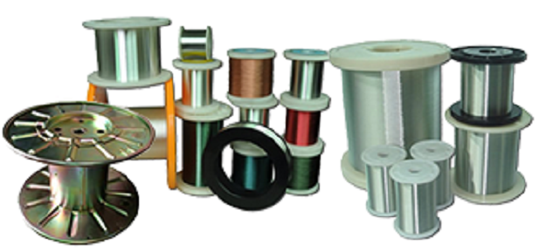

Please contact us for further details of these products: CLICK HERE (goes to email link – ownline@msn.com)

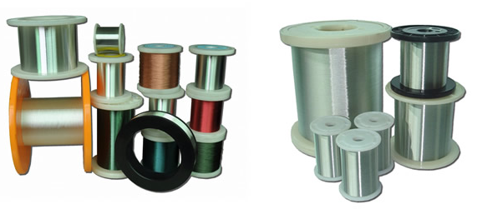

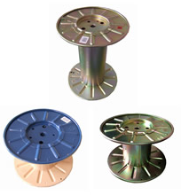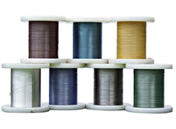
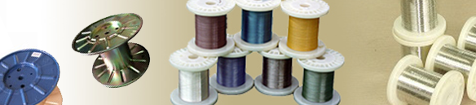

Split type and VRF air conditioner systems
Since started of our import business, REMANs have been imported and successfully distributed
Split type air conditioner like Ceiling split, Wall split and Floor standing split types, afterward we have
Successfully worked with VRF type central air conditioners with new technological systems with low consumption of power with environ friendly features.
Vacuum cleaner:
We have imported vacuum cleaner from Germany and Italy, those were having low power consumption with long lasting motor with powerful sucking power.

Switch, Sockets and Extension power plugs:
We have been imported LGLS brand miniature circuit breakers, FME brand Italian extension power sockets and plug switch products.

Lamps and Lightings:
We have imported Toshiba and Hitachi brand Fluorescent lamp and lightings.
Hence we are now concentrating to import LED lightings which will provide low cost benefit to the users in power consumption.

